EXP 12: 5G Throughput vs SNR with Modulation Labels
AIM :
To analyze and compare the throughput performance of different 5G modulation schemes (QPSK, 16QAM, 64QAM) as a function of Signal-to-Noise Ratio (SNR) using Shannon capacity theory, and to visualize their throughput curves on a single plot.
THEORY :

5G Modulation Schemes
5G uses adaptive modulation to efficiently utilize spectrum depending on channel quality:
- QPSK → 2 bits/symbol
- 16QAM → 4 bits/symbol
- 64QAM → 6 bits/symbol
Higher-order modulation increases data rate but requires higher SNR.

2. Signal-to-Noise Ratio (SNR)
SNR (in dB) is a measure of signal strength relative to background noise:
$$SNR_{linear}={10}^{\frac{SNR_{dB}}{10}}$$
Higher SNR → better channel quality → supports higher modulation.

3. Shannon Capacity
The theoretical maximum data rate (capacity) of a channel is:
$$C=B{log⁡}_{2}(1+SNR)$$
where
$B$= bandwidth (100 MHz),
$SNR$= linear SNR.
This capacity is used as a reference to estimate throughput for each modulation.

4. Throughput Scaling
Throughput is scaled relative to bits per symbol:
$$Throughput=C×\left(\frac{k}{6}\right)$$
where
$k$= bits per symbol for the modulation scheme,
6 = bits per symbol for 64-QAM (reference).
This models practical 5G performance, where higher modulations approach Shannon capacity more closely.

PROCEDURE :
- Initialize Parameters
  - Bandwidth = 100 MHz
  - SNR range = 0 to 30 dB
  - Modulation schemes = QPSK, 16QAM, 64QAM
  - Bits per symbol = 2, 4, 6
- Create an array to store throughput values for each modulation and SNR level.
- Convert SNR from dB to linear using
$${10}^{\frac{SNR_{dB}}{10}}$$
- Compute Shannon capacity for each SNR value.
- Scale throughput using bit-per-symbol efficiency relative to 64-QAM.
- Store the throughput values in a matrix.
- Plot throughput vs SNR
  - Use different colors for each modulation
  - Add labels at end of curves
  - Mark axes, title, and grid
- Analyze the plot comparing throughput of each modulation scheme.

PROGRAM :
clear; clc; close all;
%% PARAMETERS
BW = 100e6; % Bandwidth in Hz (100 MHz)
SNR_dB = 0:5:30; % SNR range in dB
mod_schemes = {'QPSK','16QAM','64QAM'}; % Modulation schemes
bits_per_symbol = [2 4 6]; % Bits per symbol
throughput = zeros(length(mod_schemes), length(SNR_dB));

%% CALCULATE THROUGHPUT
for m = 1:length(mod_schemes)
k = bits_per_symbol(m); % bits per symbol
for s = 1:length(SNR_dB)
snr_linear = 10^(SNR_dB(s)/10); % Convert dB to linear
C = BW * log2(1 + snr_linear); % Shannon capacity in bits/sec
throughput(m,s) = C * (k/6); % Adjust relative to 64QAM efficiency
end
end

%% PLOT THROUGHPUT
figure;
colors = {'b','r','g'}; hold on;
for m = 1:length(mod_schemes)
plot(SNR_dB, throughput(m,:)/1e6, 'LineWidth',2, 'Color', colors{m});
% Add text label at the end of the curve
text(SNR_dB(end)+0.5, throughput(m,end)/1e6, mod_schemes{m}, 'Color', colors{m}, ...
'FontWeight','bold','FontSize',10);
end

grid on;
xlabel('SNR (dB)');
ylabel('Throughput (Mbps)');
title('5G Throughput vs SNR for Different Modulation Schemes');
xlim([min(SNR_dB) max(SNR_dB)+5]); % leave space for label
OUTPUT :

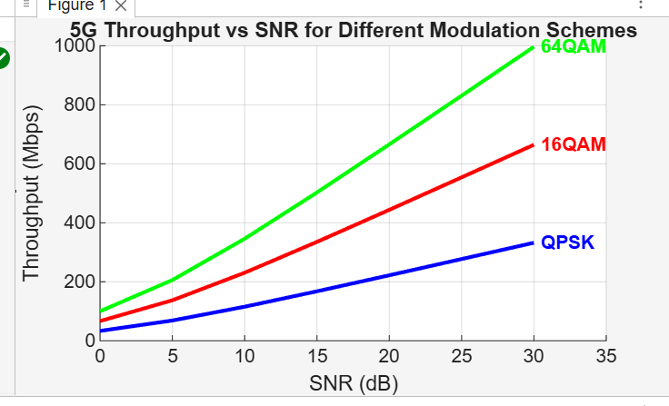
CONCLUSION :
The throughput for all modulation schemes increases as SNR increases.Higher-order modulations like 64QAM provide higher throughput but require high SNR to perform efficiently.
Thus, 5G adapts modulation based on channel quality to achieve the best possible data rate.

